1. **Agenda**:
   1. Classic Example for Shooting Star.
2. We studied the similar example when studying Hammer.  
   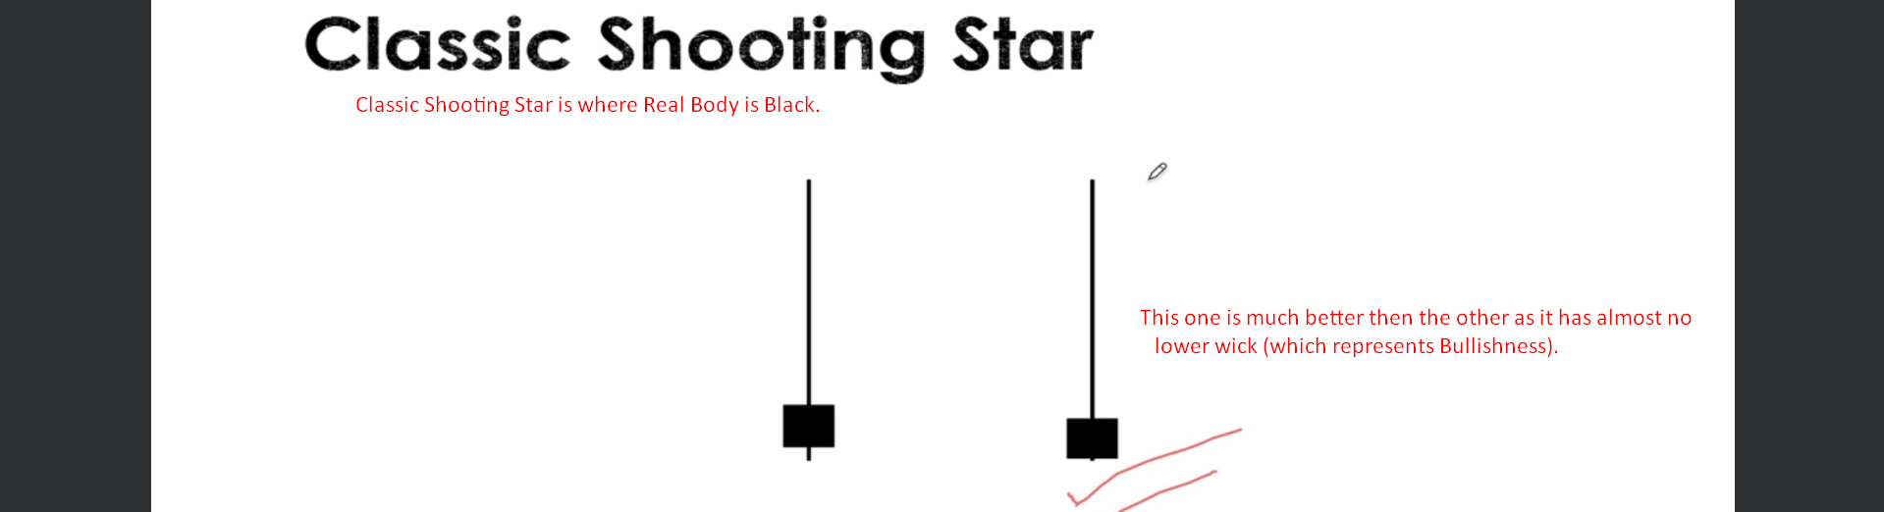
3. Let’s study one example.
4. 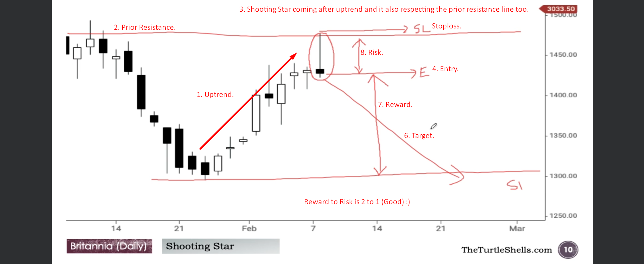  
     
   In the same chart, one more observation.   
     
   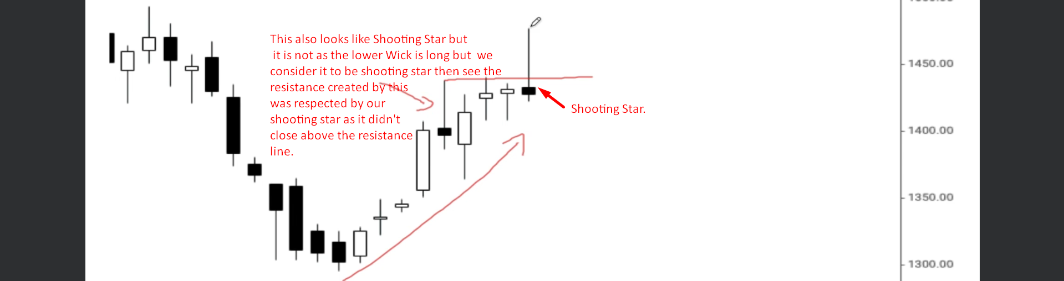
5. 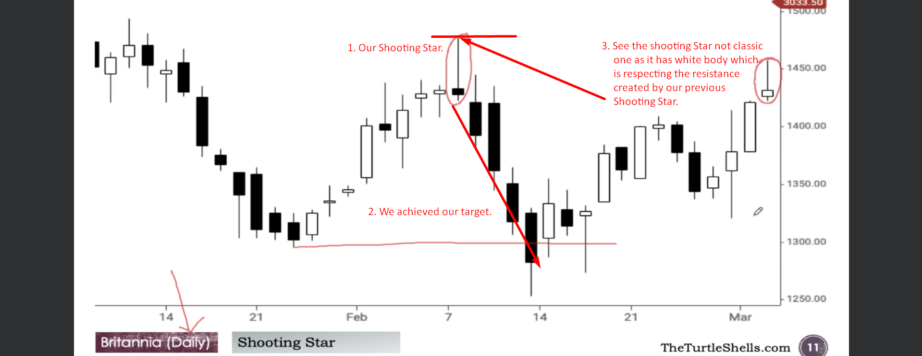  
     
   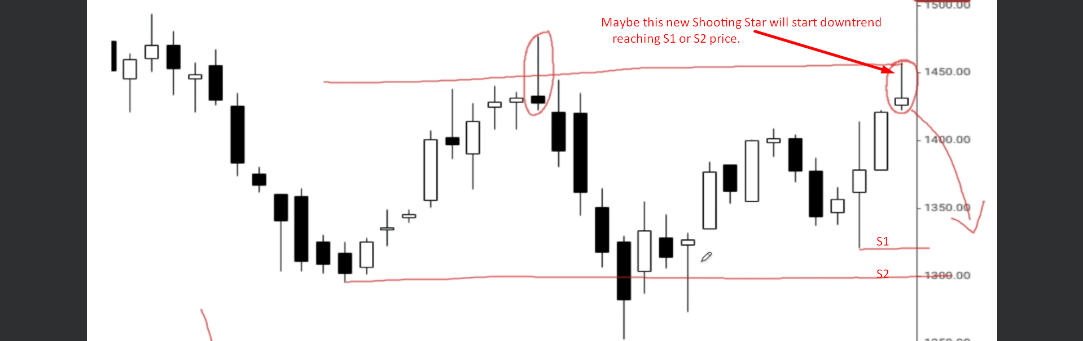  
     
   Let’s study some more patterns which appeared in the same chart after our trade for the Shooting Star.  
     
   